VIT BHOPAL UNIVERSITY


PROJECT REPORT
AI Medical Diagnosis Assistant GUI Application

Developed By : Arushi Sharma
Registration No.: 25BCE10638

Contents
INTRODUCTION 2
PROBLEM STATEMENT 2
FUNCTIONAL REQUIREMENTS 2
NON-FUNCTIONAL REQUIREMENTS 2
SYSTEM ARCHITECTURE 3
DESIGN DIAGRAMS 3
DESIGN DECISION AND RATIONALE 4
IMPLEMENTATION DETAILS 4
SCREENSHOTS/RESULTS 5
TESTING APPROACH 11
CHALLENGES FACED 11
LEARNINGS AND KEY TAKEAWAYS 12
FUTURE ENHANCEMENTS 12
REFERENCES 12

INTRODUCTION
The AI Medical Diagnosis Assistant is a Python-based desktop application designed to provide a preliminary health assessment. By bridging the gap between complex medical data and user-friendly interfaces, the tool uses a Rule-Based Expert System to categorize symptoms. The application utilizes a Depth-First Search (DFS) algorithm to navigate a specialized Directed Acyclic Graph (DAG). By treating each symptom as a node, the AI traverses deeper into specific branches based on user input until it reaches a leaf node—the final diagnosis. This deterministic approach ensures that the assistant provides logical, verifiable results, mimicking the step-by-step diagnostic reasoning of a medical professional. It aims to provide immediate clarity on common ailments like Malaria, Bronchitis, and Measles through an interactive decision-tree model.

PROBLEM STATEMENT
Self-diagnosis using traditional search engines often leads to cyberchondria —an unnecessary increase in anxiety due to conflicting or extreme medical information. Users need a structured, localized, and calm environment where they can input specific symptoms and receive a logical path toward a possible cause, accompanied by immediate safety precautions and a clear medical disclaimer.

FUNCTIONAL REQUIREMENTS
- Personalization: A registration phase to capture the user's name for a tailored experience.
- Dynamic Navigation: A button-driven interface that changes options based on the user's previous selection.
- Information Retrieval: A backend dictionary acting as a knowledge base for disease descriptions and preventative measures.
- State Management: The ability to reset the diagnosis path at any point without losing the user's session data (name).
- Visual Feedback: Highlighting the final diagnosis in a distinct, bold format to ensure clarity.

NON-FUNCTIONAL REQUIREMENTS
- Usability: The interface employs a warm UI aesthetic (Cream and Coral colours) to reduce user stress during health-related queries.
- Performance: The search logic is optimized for lookup time using Python dictionaries, ensuring zero lag during transitions.
- Reliability: The system uses a Directed Acyclic Graph (DAG) structure, ensuring the user can never get stuck in an infinite loop.
- Error Handling: Implementation of try-except concepts and if-not checks to prevent the application from crashing if a user provides empty strings or clicks buttons out of order.

SYSTEM ARCHITECTURE
The application follows a Modular Monolithic Architecture, where the UI and Logic are separated within a single class structure:
- The Knowledge Base: A static data layer containing the medical_graph (the map) and disease_info (the content).
- The Controller (MedicalAIApp): Manages the "current state" of the user.
- The View: A dynamic Tkinter Frame that clears and repopulates itself based on the Controller's instructions.

DESIGN DIAGRAMS
- Use Case Diagram: Defines the boundary between the User (Patient) and the System (AI Assistant). The User triggers "Input Name" and "Select Symptom," while the System triggers "Fetch Result" and "Show Precautions."
- Workflow Diagram:
Step 1: Input Validation
Step 2: Symptom Root (Fever/Cough/Rash)
Step 3: Severity Check
Step 4: Final Leaf Node (Diagnosis).
- Sequence Diagram: Illustrates the message passing between the dfs_search function and the update_options UI method.

DESIGN DECISION AND RATIONALE
- Tkinter Selection: Tkinter allows for a standalone .exe file, making the tool accessible offline—crucial for medical utility in remote areas.
- Procedural Graph Traversal: Instead of complex AI models (like GPT), a graph-based approach was chosen to ensure 100% accuracy based on the provided medical data.
- Component-Based UI: By using a main_container frame that is cleared using winfo_children(), the app maintains a single-window flow, which is less confusing for non-technical users than opening multiple pop-up windows.
- Color Theory: Using #FF6B6B (Coral), warm theme, instead of Emergency Red provides a sense of urgency without causing panic.

IMPLEMENTATION DETAILS
The application utilizes a Recursive-style Navigation (though implemented iteratively) to move through the medical_graph.
- Knowledge Representation:
- medical_graph: Keys are parent symptoms, and values are lists of child symptoms.
- disease_info: A nested dictionary containing key-value pairs for symptoms and precautions.
- Dynamic UI Generation: The update_options method uses a for loop to generate buttons on the fly, meaning the developer can add 100 more symptoms to the dictionary without changing a single line of UI code.

SCREENSHOTS/RESULTS
- The GUI application is waiting for name input. The “Start Diagnosis” button is active.
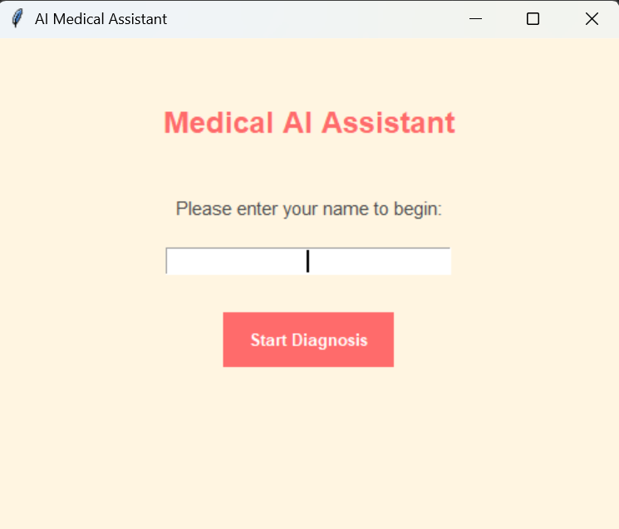
- If the user does not input his/her name, an error is given and the user is given a message to input their name.
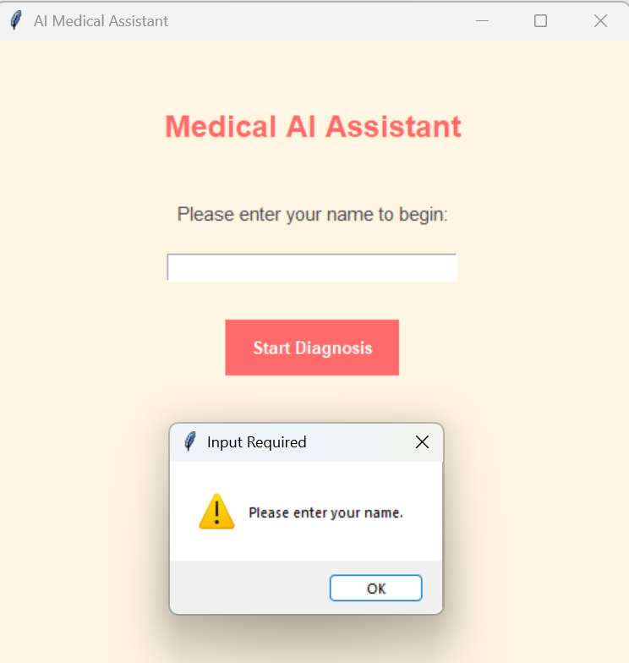

- After the user enters their name and clicks on “Start Diagnosis”, the user is shown 3 choices and the user has to choose their current symptom.
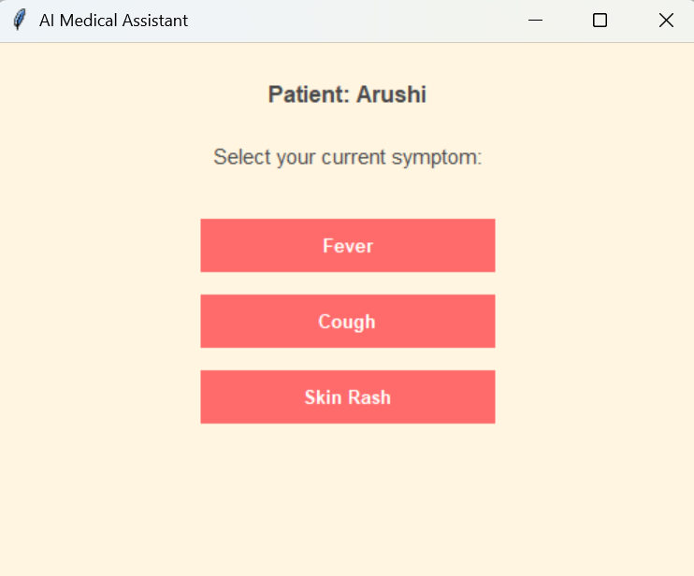
CASE-1:
If the user chooses “Fever”, 2 sub-symptoms are given and the user has to choose the symptom he/she is facing.
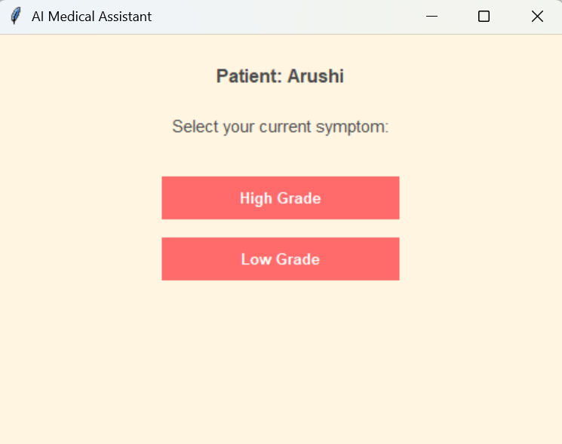
On choosing “High Grade”, the GUI applications completes the assessment.
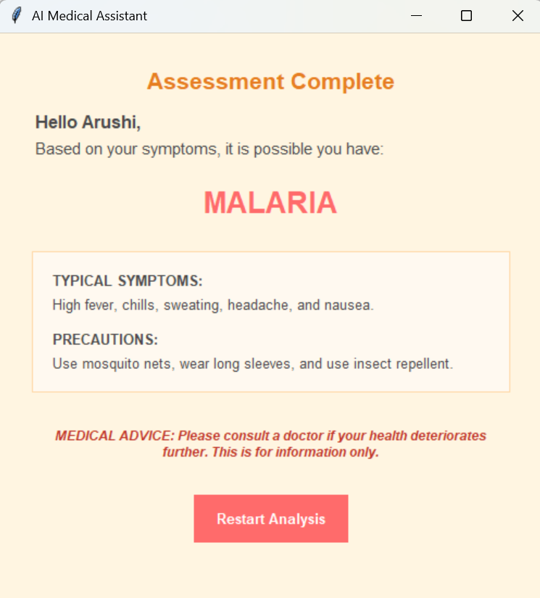
On choosing “Low Grade”, the GUI applications completes the assessment.
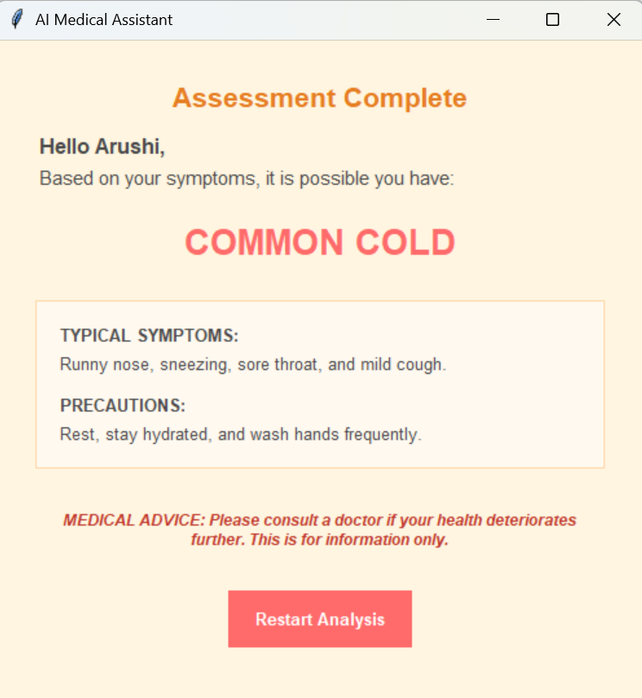

CASE-2:
If the user chooses “Cough”, 2 sub-symptoms are given and the user has to choose the symptom he/she is facing.
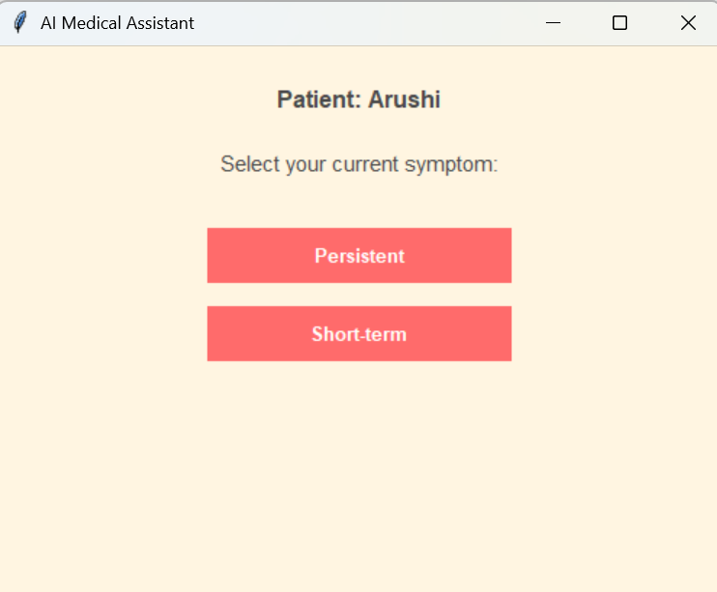
On choosing “Persistent”, the GUI applications completes the assessment.
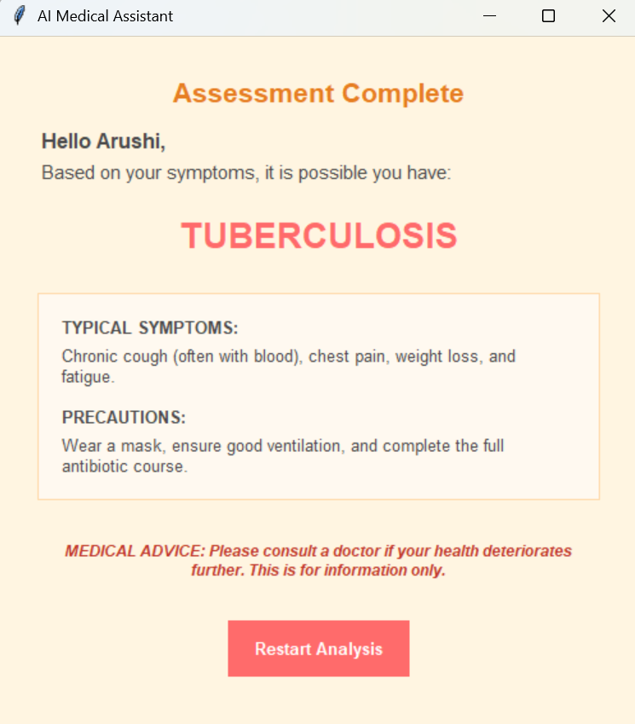
On choosing “Short Term”, the GUI applications completes the assessment.
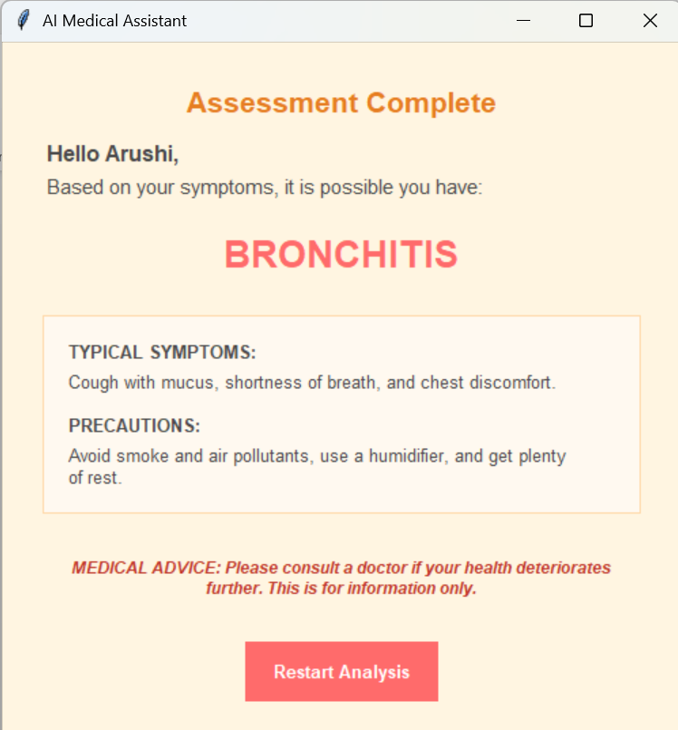
CASE-3:
If the user chooses “Skin Rash”, 2 sub-symptoms are given and the user has to choose the symptom he/she is facing.
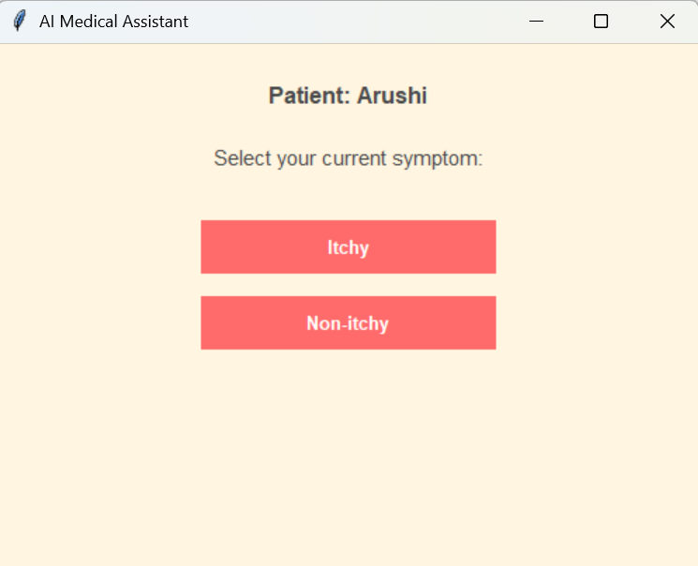
On choosing “Itchy”, the GUI applications completes the assessment.
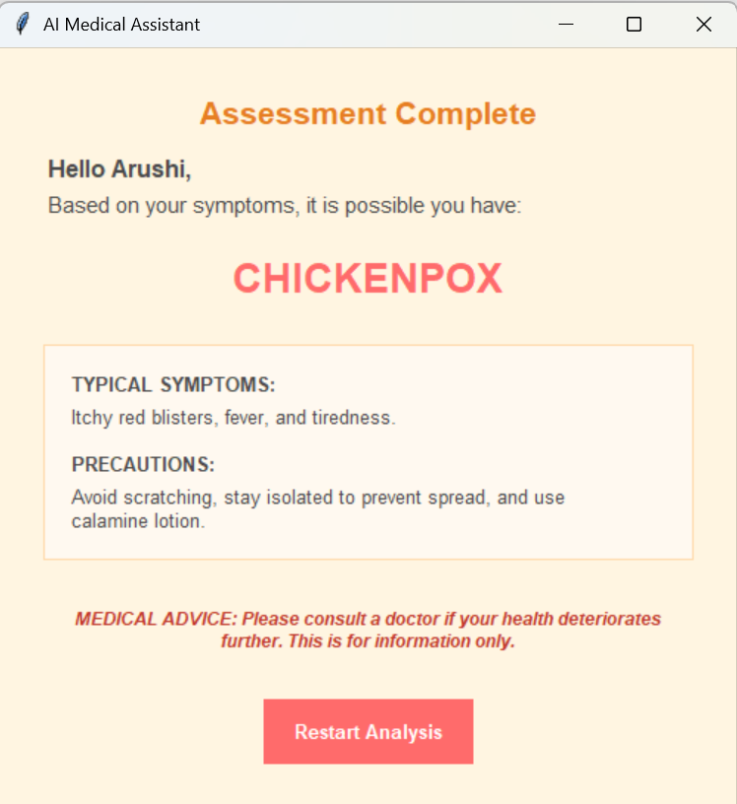
On choosing “Non-Itchy”, the GUI applications completes the assessment.
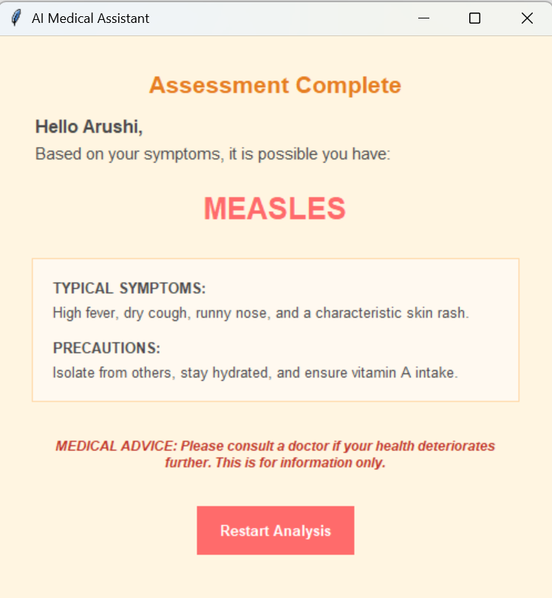
4. After every diagnosis outcome, a medical advice is given to consult a doctor if the patient’s health deteriorates. This message is written to let the user know that this is only for information purposes.
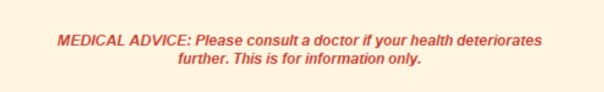
5. Below the medical advice, the “Restart Analysis” button is given to start the diagnosis again.


TESTING APPROACH
Functional Test Case Suite and Results
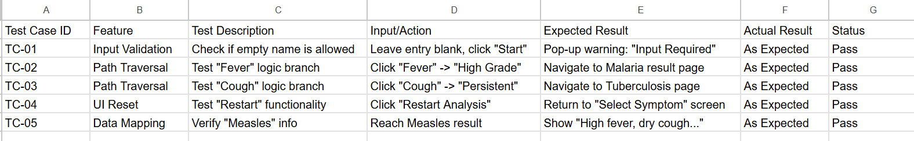
Decision Tree Data Structure Mapping
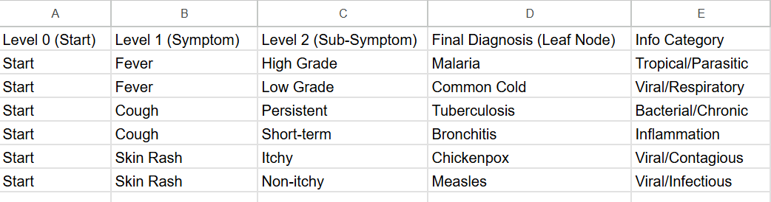

CHALLENGES FACED
  - Logic Branching: Difficulty in ensuring the Depth-First Search (DFS) accurately identified when a user reached a terminal "leaf node" versus a sub-symptom.
  - Widget Persistence: Managing the Tkinter lifecycle to prevent old symptom buttons from overlapping with new ones during screen transitions.
  - State Synchronization: Keeping the current_node variable accurately aligned with the user's real-time selections across multiple levels of the graph.
  - Data Structure Alignment: Ensuring 1:1 string matching between the medical_graph keys and the disease_info database to prevent application crashes.
  - Input Validation: Preventing the Inference Engine from executing when the user profile (name entry) was left null or contained only whitespace.
  - UI Constraints: Balancing the display of detailed medical precautions within a fixed window geometry without sacrificing readability.

LEARNINGS AND KEY TAKEAWAYS
- Data Structures: Mastering how to represent real-world logic (medical triage) using Python Dictionaries.
- Event-Driven Programming: Understanding how command=lambda allows passing arguments from a button to a function in Tkinter.
- UX Design: Realizing that font size and button padding significantly impact the "professional feel" of a medical tool.

FUTURE ENHANCEMENTS
- Speech-to-Text: Integration of Python's speech_recognition to allow elderly users to speak their symptoms.
- Export Feature: A "Print to Text" button to allow users to take their results to a physical doctor.
- Visual Aids: Adding images of rashes or symptoms to help users make more accurate selections.

REFERENCES
TKINTER REFERENCES:
- Tkinter Official Documentation
- https://www.geeksforgeeks.org/python/python-gui-tkinter/
- https://www.educative.io/answers/what-are-the-basic-functions-of-tkinter-in-python
DISEASES, SYMPTOMS AND CAUSES REFERENCES:
1. Measles-
https://www.mayoclinic.org/diseases-conditions/measles/symptoms-causes/syc-20374857
2. Chickenpox-
https://my.clevelandclinic.org/health/diseases/4017-chickenpox
3. Bronchitis-
https://my.clevelandclinic.org/health/diseases/3993-bronchitis
4. Tuberculosis-
https://www.mayoclinic.org/diseases-conditions/tuberculosis/symptoms-causes/syc-20351250
5. Common Cold-
https://my.clevelandclinic.org/health/diseases/12342-common-cold
6. Malaria-
https://www.mayoclinic.org/diseases-conditions/malaria/symptoms-causes/syc-20351184

